## Week 1

[Wilson] **Consilience:** unity of knowledge in different disciplines

[Huxley]: Taking mescaline allowed him to take in more perceptual input

How did life come about?

* **Neg-entropic**: a system working to keep itself in being, stave-off entropic collapse (like Life)
* **Autocatalytic** systems: self-reinforcing (catabolism: break down and release energy vs anabolism)
  + By capturing, storing and transforming external energy into internally useful forms
* **Autopoesis**: self-perpetuating to keep themselves in existence (end-directed)
  + Leads to evolution of movement and selective detection/ intake of useful external substances
  + Teleonomy: means towards an ends
* **Emergence** of **gestalt** properties due to interactions (whole is more than parts)
  + Vs **Fundamentalist Reduction**
  + Vs **Downward Causation**: Top-down constraints on constituents (alt definition)

[Smolin] Gaia Hypothesis: Life only possible in a steady-state, not in equilibrium. Steady flow of energy in and out 🡪 level of organisation (instead of entropy) increases over time.

* Living system:
  + **Self-organised, non-equilibrium system** (boundaries, energy flow, chemical cycles stabilized by feedback loops)
  + Governed by symbolic program that can reproduce itself
* Universe itself must be a nested hierarchy of self-organised, non-eq systems

[Kauffman] Lift exists on the edge of chaos. Spontaneous order is emergent

* Too much order 🡪 potential spent; too much chaos 🡪 unspent potential

## **Week** 2

**Perception: Sensation that has become meaningfully arranged**

* Arises from the need of a system to find what it needs in the external world beyond self
* Living creatura vs non-living pleroma

[Uexkull] Umwelt - the body produces the mind. Action-based perceptual relations.

* **Sign relationships**: organism evolved the ability to use some aspect of the world to represent something other than what the thing is in itself
* Action is what give external things **meaning** (a relational world)
* Not just genes that survive, but also patterns of interpretation

**Icon**: smallest unit of info is a difference that makes a difference to an organism

* Iconic relations 🡪 experience
* Evolutionary hierarchy of reference from iconic 🡪 indexical 🡪 symbolic

Unicellular Reflex System [Stimulus 🡪 Response in a purpose-serving structure]

* Mediating interneurons process sign relations and exponentially increase the possible combinations
* Ablation: Stoppage of neuronal firing at any point in the process
* Brain develops to coordinate when cells specialise into sensory and motor functions

[LLinas]

* **Teleception**/ remote sensing increases predictive capacity of negotiating the external world
* Exploit **universal properties of light and electromagnetism** 🡪 neurons behave the same
* Marble analogy 🡪 no intentional design
* Gelatin analogy 🡪 neuroplasticity
* Strange geometry: we do not represent exactly as it is

[Godfrey] Action-shaping view of early nervous systems

* Embodied cognition: animal’s body creates constraints. opportunities, guiding its actions
* **Reafference**: Action affects perception
* Cambrian explosion / information revolution (542mya) 🡪 interaction and evolutionary feedback. The mind evolved in response to other minds.
* Fork (600mya): separation of vertebrates and invertebrates. Vertebrates and cephalopods separately evolved camera eyes.
* Consciousness is one form of subjective experience. Sentience comes before consciousness.
* Memory: communication between present and future self
* Multicellular: need to communicate between cells (via chemicals or nervous system)
* Feedback loop: action affects sensing

Modern Synthesis: natural selection + Mandel’s knowledge of the existence of genotypes

* Llinas’ Law of Laziness: evolutionary tendency towards optima over maxima

## Week 3

Methods of Brain Research: ablation, invasive imaging, non-invasive imaging

Brain Imaging Techniques:

* EEG: electrical activity
* CAT: piece together X-ray images
* MRI: CAT with 3D imaging and better resolution
* PET: trace uptake of radioactive particles
* fMRI: measure oxygen levels (indicating blood flow)

Consciousness

* Chalmers: explanatory gap from non-conscious 🡪 conscious entities
  + Could be misled by our use of metaphors
* Cartesian Theater: Homunculus infinite regress

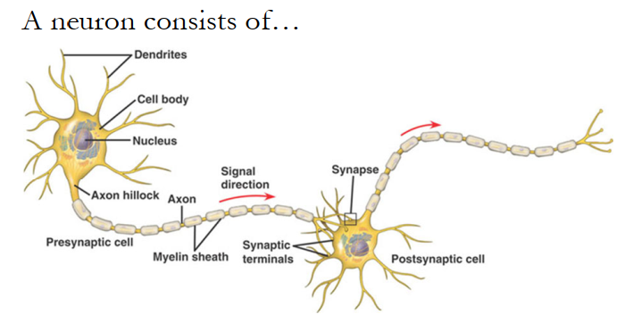

Myelin sheath covered by glia cells for insulation

Neural summation at the axon hillock

Gap junctions: Hollow, fluid-filled connexon cylinders

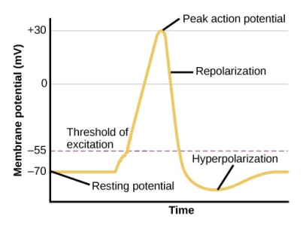Semi-permeable membrane; ATP-driven Na-K Pumps maintain the resting potential of the membrane by continually ‘resetting’ the levels of K+ relative to Na+

Electrochemical gradient at play

Action potential at -55mV 🡪 voltage-gated Sodium channels open

+30mv 🡪 Potassium channels open, left open for too long

* Action potentials are always the same; can only vary their frequency
* Slower-response voltage-gated calcium channels involved in muscular contraction

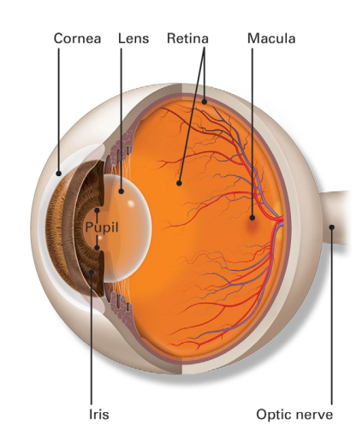

**Cornea**: Protection, refraction

* Glaucoma: pressure in aqueous humour too large 🡪 retinal damage

**Lens**: accommodation (variable focusing)

* Myopia, hyperopia, presbyopia
* Inverse optics problem: image on retina is vertically inverted

**Iris**: adjust size of aperture (**pupil**)

**Fovea**: depression at the **Macula** (high concentration of cones)

**Pigment Epithelium**: transport nutrients to retina

Blindspot/ optic disk: axons of ganglion cells leave eye at optic nerve

* Phototransduction: process of light -> electrochemical energy
* Normal: slightly depolarised; Prescence of light: hyperpolarised (a change)

## Week 4

Ganglion, Bipolar, Amacrine, Horizontal, Photoreceptors (respond to light)

* RGCs have M, P, K types. Able to fire action potentials (others are graded)
* Intrinsically photosensitive **ipsRGC**: melanopsin to respond directly to light by depolarising
* Regulate circadian rhythm

**Graded potentials**: localised charge differences (EPSP, IPSP)

* Input proportional to stimulus with spatial and temporal summation
* No threshold or refractory period
* **Summation at axon hillock** 🡪 action potential

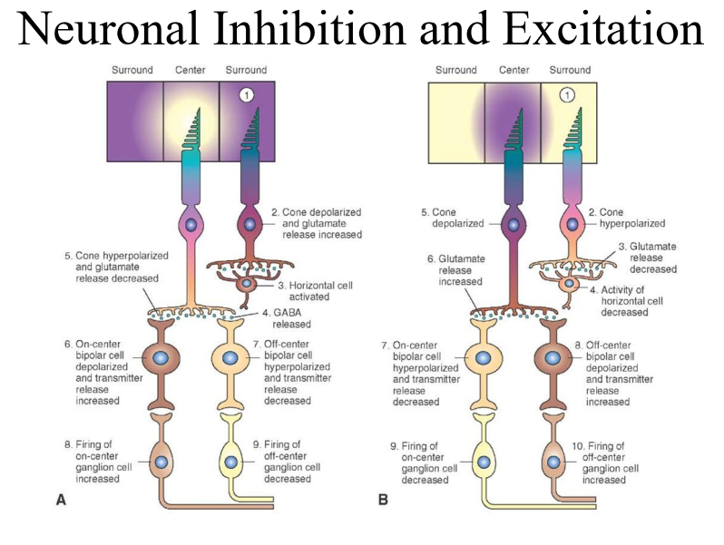

Neurotransmitters: Amino Acids

* Synthesised in neuron 🡪 released cell is depolarized 🡪 binds to post-synaptic cell or effector organ 🡪 mechanism for reuptake from synaptic cleft
* Glutamate: Excitatory amino acid neurotx
  + Na+ channels open → depolarising graded potentials
  + **ON bipolar cells; Metatrobic mGluR6** receptors inhibited by glutamate
    - Hyperpolarise cell (increase activity with response to light)
    - **Inverse effect** from photoreceptors
  + **OFF bipolar cells; Ionotropic AMPA** receptors excited by glutamate
* GABA: inhibitory amino acid neurotx
  + K+ efflux or Cl- influx channels open 🡪 hypoerpolarising graded potentials
  + Synthesised from Glutamate
  + Unable to inhibit muscles 🡪 Huntington’s Parkinson’s
* Antagonist: opposes effect of neurotx; Agonist: mimic effect of neurotx

Neurotransmitters: G-protein coupled modulation

* Slower action, working through effector proteins

Darkness: high cGMP; steady inward flow of Na+ (depolarised at -40mV)

* Light: discharge steady stream of neurotx until G-protein coupled photoreceptors (opsins) synthesised in RPE deformed
* **Begins metatrobic process degrading cGMP** 🡪 Na+ channels close, cell hyperpolarises until **less Glutamate is released**
  + ON bipolar cells are less inhibited; OFF bipolar cells are less excited

Receptive field: collection of input photoreceptors synapsing to a neuron

Center-Surround Processing

* Edge detection begins in retina
* Horizontal cells: lateral cells between photoreceptors and bipolar cells
  + Excited by glutamate 🡪 depolarizes and releases inhibitory GABA and hyperpolarises photoreceptors
  + Modulates graded potential received by bipolar cell; prevent saturation of retina’s response range
* Light only in center 🡪 horizontal cells inhibit center cone and less glutamate 🡪 ON bipolar most excited
* Light everywhere 🡪 horizontal cells less excited; inhibit center cone less 🡪 ON bipolar less excited
* Light only in surround 🡪 horizontal cells least excited; least inhibition to center cone and most glutamate released 🡪 bipolar cells most inhibited
* Amacrine cells: modulate output from bipolar cells to RGCs; enhance edge detection

RGC Receptive fields: Example of ON-center OFF-surround

* Light on center 🡪 RGC most excited; light on center + surround 🡪 no change in response
* Detect relative presence of light in dark environments
* How to detect light intensity?

Lateral inhibition: excited neuron reduces activity of neighbours; accentuates edge detection

## Week 5

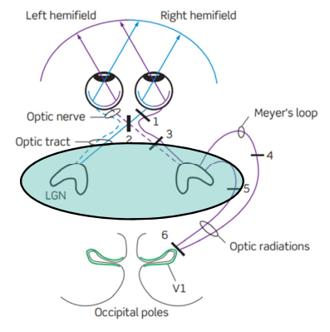LGN: connects optic tract to primary visual cortex (V1)

* M cells from rods for motion and flicker; P cells from cones for colour
* Axons from RGCs on nasal hemi-retina path cross over to other LGN

Retinotopic mapping preserving adjacency 🡪 temporal and spatial decorrelation (distinguishing) of signals

* Segregate information by type, to make it easier for visual cortex to process 🡪 recorrelation in visual cortex

Top-down input from cortex and brainstem

LGN sends input to orientation columns (mix of simple & complex)

* Orientation columns 🡪 hypercolumns which communicate via shorter horizontal axons
  + **Hypercolumn** is a set of columns responsive to lines of all orientations from a particular region in the visual field and viewed by both eyes
* Depth perception: two eyes 🡪 compare info in adjacent columns (interaction dissonance)

Simple cell receptive field in V1 is like a rectangularised version of circular RF

* Orientation selectivity; sensing direction and movement
* Complex cells: higher-order receptive fields combined with OR logic
* Hypercomplex cells: end-stopped receptive fields 🡪 length-sensitive; existed debated
* Response selectivity: do we have a grandmother cell?

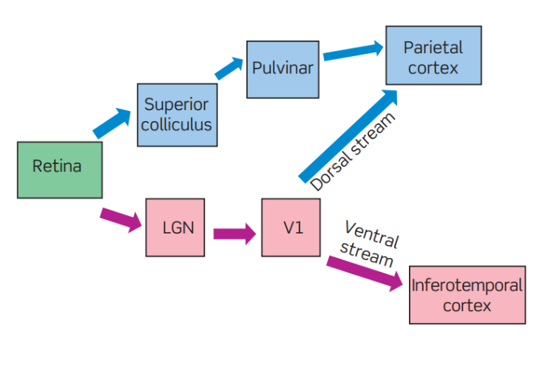Striate V1 🡪 extrastriate visual cortex

- **Dorsal** where/ how stream; **Ventral** what stream

**Blindsight**: V1 damage, but can respond to stimuli they cannot see (input from K cells to MT in V5)

**Optic ataxia**: Parietal cortex damage; visual perception but cannot interact w objects

**Agnosia**: Inferotemporal cortex damage; unable to recognize/ interpret visual input

Churchland [“Semi-world” hypothesis and interactive vision (vs pure vision)]

* Only a partial representation of the world is needed
* Interactive vision is exploratory and predictive
  + Multi-modal processing including auditory input and memory
  + Decision-making on saccadic eye movement done prior to visual awareness
* Hebbian plasticity: Neurons that fire together, wire together
  + Rich recurrences (heterarchy) and back propagation

## Week 6

[Edelman]

- Thalamo-cortical System: integrate specialists together for **perception**; highly-specialised

- Hippocampal-Cerebellar-Basal Ganglion Loops: uni-directional. Complex motor actions and cognition more functionally isolated

- Diffusely Projecting Neurotransmitter “Value” System: salient events 🡪 entire brain

Developmental selection (**neural pruning**), Experiential selection (**neural plasticity via LTP/ LTD**), Reentrant mappings

Brain’s second evolution during our lifetime

Hebbian plasticity: synaptic strengthening/ **LTP** potentiation vs weakening/ **LTD** depression

* Addition/ up-regulation and removal/ down-regulation of receptor cells
* Functional cluster: transiently more connected 🡪 sensor-effector cognitively functional units/ engrams. Engrams allow world to be partitioned without a central controller

**Theory of Neuronal Group Selection (TNGS)** / Neural Darwinsm

* Re-entry: multiple parallel paths vs feedback: single loop
* Rich recurrences applied to whole brain
* Degeneracy: unavoidable consequence of selection system 🡪 robustness
* **Value**: constrain selection system; precondition for categorical response (e.g. how the hand was shaped). Nested selective system: result of natural selection 🡪 phenotypic constraints on somatic selection
* High values of complexity 🡪 functional specialization and integration
  + “Reduction of informational entropy”
  + Mutual information between subset and the rest of the system
  + Specialisation: system can take many states; Integration: high mutual information
* Complexity facilitates variation for selection

Brain Parts (Big 12)

|  |  |  |  |
| --- | --- | --- | --- |
| Thalamus: relay center | Hypothalamus: endocrine system | Amygdala: emotions | Hippocampus: memory (ST 🡪 LT) |
| Prefrontal cortex: executive functions (higher-order cognition) | Corpus callosum: connect left and right cerebral cortex | Broca’s area: speech and language | Wernicke’s area: speech and language |
| Primary motor strip: control contralateral body movement | Primary sensory strip: process somatic/ bodily sensations | Basal ganglia: planning and executing movement | Cerebellum: balance, posture (fine-motor actions) |

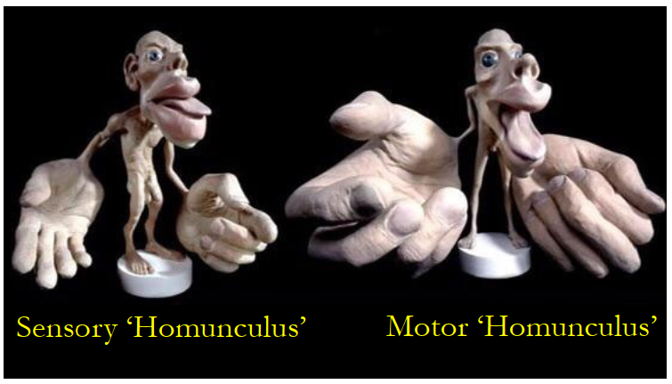

Sensory and motor homunculus

## The Symbolic Species

Reference: Interpretive process for things to refer to something else

* Not intrinsic to a word, but created by the nature of the response
* Interpretant = interpretive response; brings sign and referent together
* E.g. I interpret X to be an icon/ index/ symbol (different levels of interpretation depending on interpreter)

Hierarchical categories of referential associations (semiotic reductionism)

* **Icon**: isomorphism/ resemblance / similarity when we do not make a distinction
  + Interpretive process of re-cognition; re-presenting objects
* **Index**: repeated physical/ temporal correlation/ co-occurrence
  + 3 iconic relations: stimulus is icon of similar instances, stimulus correlates with additional stimuli iconic of one another, past correlations are interpreted as icons
  + Example: stimulus generalization (transferring stimulus/ learning set) grouped together via iconic overlap instead of symbolic criteria. E.g. rhyming
* **Symbol**: social convention
  + From indexical associations, but remains stable w/o physical correlations (reference)
    - Dependent but not reducible
  + Symbols represent other symbols (sense); indexical power distributed in relationships between words
    - Similar referential function 🡪 words not used together (inverse true)
  + Unlike icon/ index, symbolic repr. is partially externally interpreted (shared)
  + Shift in mnemonic strategy to **rely on symbols to rmb objects** (reduce redundancy)
    - Enables logical/ categorical generalization
    - Able to learn multiple potentially competing associations (competing at indexical level, supporting at symbolic level due to associative redundancy)
  + Implicitly combinatorial entities
  + Each interpreter independently supplies nonsymbolic ground

Rumbaugh Monkey experiment: Sherman and Austin vs Lana

* S/A learned logical relationships (symbolic recoding) between lexigrams; found the iconic relation between two systems of indices
* L: rote learning (associative learning strategies can interfere w symbol learning)

Consciousness

* Language is a means of symbolic representation
  + Allows us to distance from our own thoughts and represent ourselves (symbolic self)
* Symbolic compulsion to see ourselves as symbols (find purpose)
* Source of symbolic reference is not the brain, but in relationships constructed by brain
* Mental experience mediated by repr. 🡪 to be conscious is to experience representation
  + Chinese Room Experiment: consciousness of indexical representations
  + Humans: conscious of symbolic representations